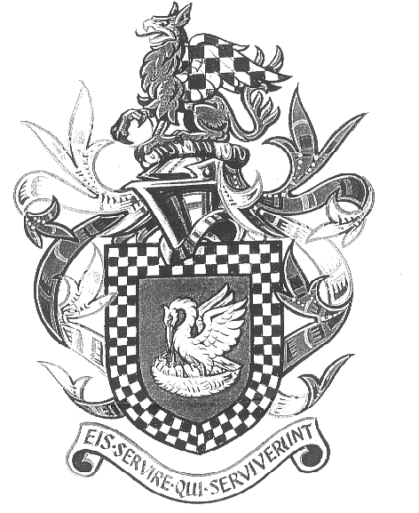

Committee Meeting 7 pm Thursday 10th October 2024

Wakefield House (Federation Building)

Agenda

- Attendance and Apologies

- Minutes of the meeting held 17th July 2024

- Matters Arising

- Treasurers Report (MJ) (Attached)

- NARPO Trustee update (DS)

- Pensions Update (TK)

- WEBSITE (NP)

- Social Calendar (DW)

- Welfare (Confidential)

- AOB

- Date of next meeting Thursday 10th October 2024 at 7pm

